Create two tables(employee and Department)Not Null,  
Primary Key  
Foreign Key  
Unique Key  
Default  
Check

1.Primary Key

**CREATE** **TABLE** LV_DEPT1

(

DEP_ID **INT** **PRIMARY** **KEY**,

DEP_NAME **VARCHAR**(30) **UNIQUE**

)

**INSERT** **INTO** LV_DEPT1 **VALUES**(10,'DATABASE')

**INSERT** **INTO** LV_DEPT1 **VALUES**(20,'IT')

**INSERT** **INTO** LV_DEPT1 **VALUES**(30,'FULL STACK')

**SELECT** * **FROM** LV_DEPT1

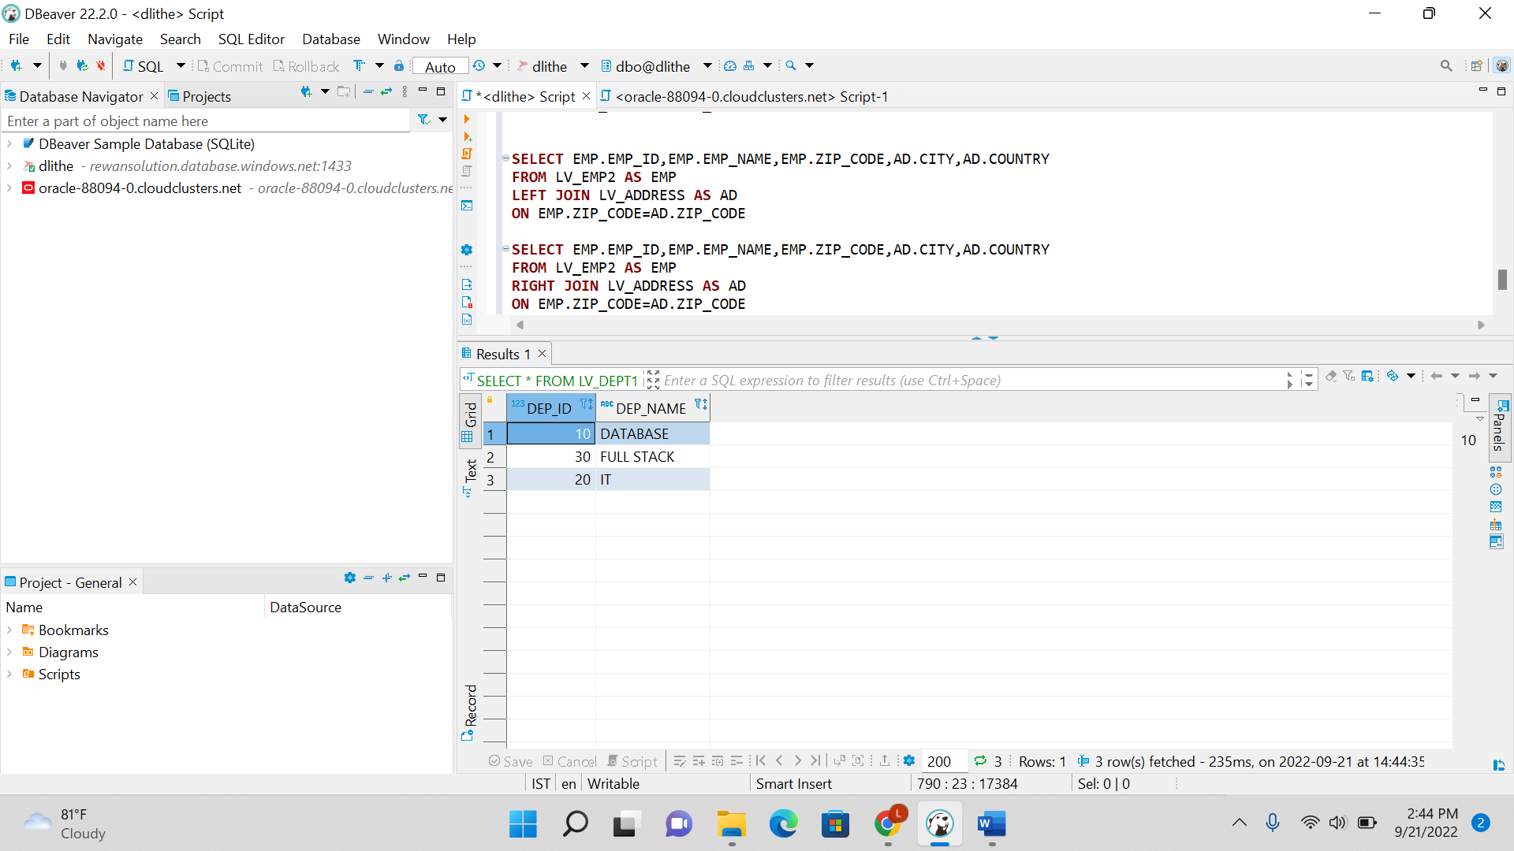

2. Foreign Key

**CREATE** **TABLE** LV_DEPT1

(

DEP_ID **INT** **PRIMARY** **KEY**,

DEP_NAME **VARCHAR**(30) **UNIQUE**

)

**INSERT** **INTO** LV_DEPT1 **VALUES**(10,'DATABASE')

**INSERT** **INTO** LV_DEPT1 **VALUES**(20,'IT')

**INSERT** **INTO** LV_DEPT1 **VALUES**(30,'FULL STACK')

**SELECT** * **FROM** LV_DEPT1

**CREATE** **TABLE** LV_EMP3

(

EMP_ID **INT** **PRIMARY** **KEY**,

EMP_NAME **VARCHAR**(30),

DEP_ID **INT** **FOREIGN** **KEY** **REFERENCES** LV_DEPT1(DEP_ID)

)

**INSERT** **INTO** LV_EMP3 **VALUES**(1,'ANANYA',10)

**INSERT** **INTO** LV_EMP3 **VALUES**(2,'ANAGHA',20)

**INSERT** **INTO** LV_EMP3 **VALUES**(3,'BHAVANA',30)

**SELECT** * **FROM** LV_EMP3

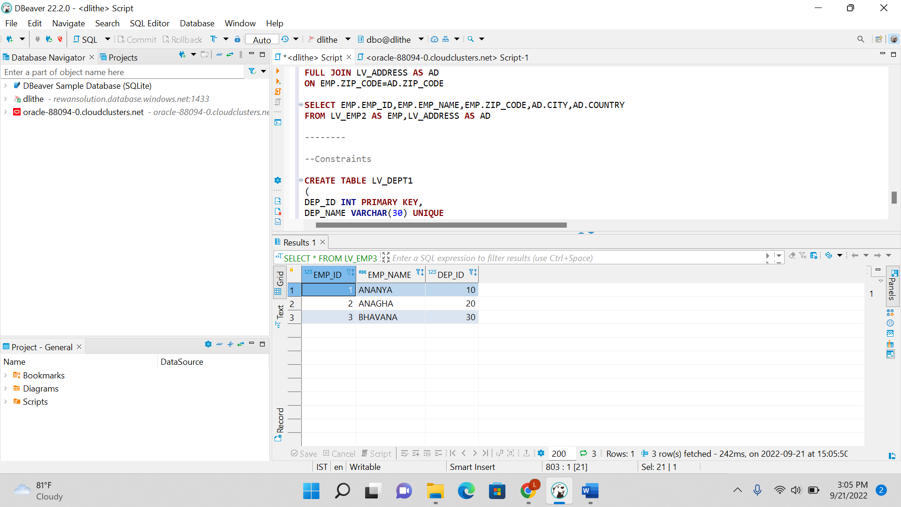

3. Unique Key

**CREATE** **TABLE** LV_DEPT1

(

DEP_ID **INT** **PRIMARY** **KEY**,

DEP_NAME **VARCHAR**(30) **UNIQUE**

)

**INSERT** **INTO** LV_DEPT1 **VALUES**(10,'DATABASE')

**INSERT** **INTO** LV_DEPT1 **VALUES**(20,'IT')

**INSERT** **INTO** LV_DEPT1 **VALUES**(30,'FULL STACK')

**SELECT** * **FROM** LV_DEPT1



4. Default

**CREATE** **TABLE** LV_EMP6

(

EMP_ID **INT** **PRIMARY** **KEY**,

EMP_NAME **VARCHAR**(30),

AGE **INT** **DEFAULT** 18

)

**SELECT** * **FROM** LV_EMP6

5. Check

**CREATE** **TABLE** LV_EMP4

(

EMP_ID **INT** **PRIMARY** **KEY**,

EMP_NAME **VARCHAR**(30),

AGE **INT** **CHECK** (AGE>=18)

)

**INSERT** **INTO** LV_EMP4 **VALUES**(1,'SITA',18)

**INSERT** **INTO** LV_EMP4 **VALUES**(2,'GITA',19)

**INSERT** **INTO** LV_EMP4 **VALUES**(3,'RITA',20)

**